Word Scramble
  - Overview
- Introduction and Context
The distributed application our group is building will be a two-player game called Word Scramble. It will largely be based off the board game Scrabble but will have some key differences in game play. Each player will be given an allotted number of letters and will take turns spelling out words on a 16 x 16 tile game board. When a player places a word on the board, that word is checked against a dictionary of valid words. If the word is valid, then the turn is passed to the other player. There is no restriction on where a new word can be played on the game board. Play continues until the game board is filled and no new words can be played. The player with the least number of remaining letters is the winner.
This application will allow us to meet the requirements for this project in the following ways: The application will consist of three distinct shared resources, utilizing a database for the dictionary and to store user information, a XML file that updates dynamically with front-end server addresses, and a shared object in the form of a game board. We will have a Database Server, a Referee Server, and a client program that will communicate and allow for seamless game play. There will be several communication protocols in the application using both TCP/IP and UDP protocols. The scope of this application will challenge our skills and abilities but will be attainable within the course time frame.

- Actors and their Goals
We have identified three actors that have separate goals. The Actors are Users, Referee server, and Database Server. The Users goal will be able to create an account. After account creation the User will be able to Log In to the client. After the User has logged in the User will request a new game. Inside the game a User will be able to place letters, request new letters, submit a word, send a heartbeat, reply to a heartbeat, and end the game. The Database server will serve as the dictionary database, the user database, played game database, and contain a register of Referee Servers. The Database Server will be able to create a dictionary, send a heartbeat, reply to heartbeats, receive information from a referee, update user information, receive words, search for words, and reply to say if the word is allowed, and update played game results. The final actor is the Referee server. The Referee Server will be sending heartbeats to both the Database Server, as well as the User Client. If the User does not respond it ends the game and notifies the second player. If the Database server is not replying it temporarily pauses all games, it is overseeing and tries to reconnect. After a certain time, it will throw an error and end the game. When the Referee receives a new game request, it will attempt to connect two players together. After it connects to both players it will start to send game update messages. After a game exits it will send an update to the Database Server. Finally, when the server is launched it will send its information to the Database Server so the Database Server can sed it to a User Client.

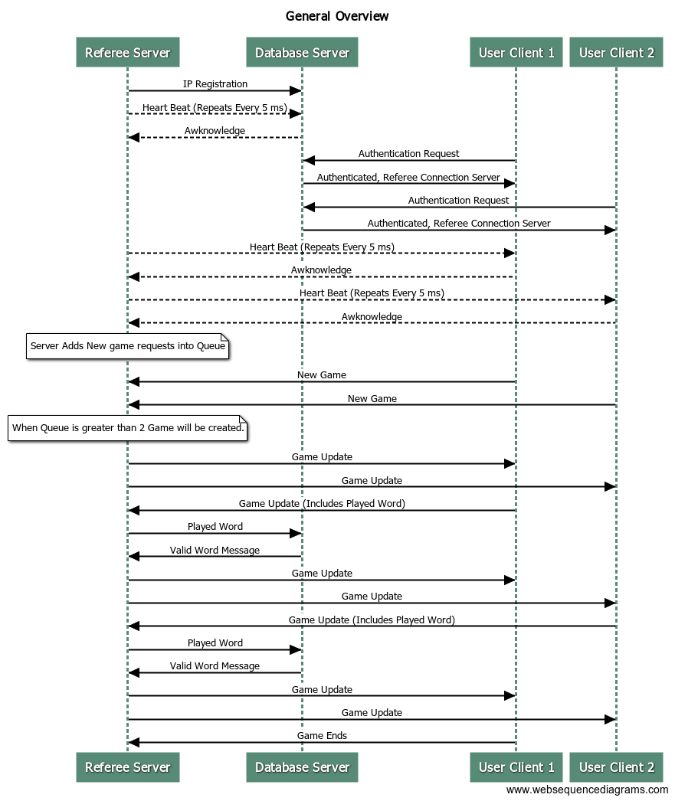
- Major Components and Their Relationship

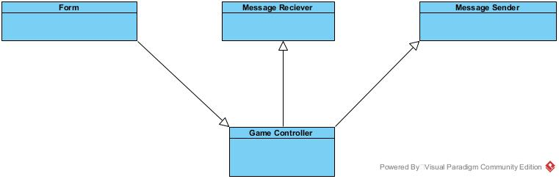
The above image shows the Process of the game. There are three process. User Clients, Referee Server, and a Database Server. The general process is displayed in the image above.

The User Client will consist of the Form class that will contain the GUI of the application. The Form object will contain a Game Controller Object. The Game Controller Object will Contain A Message Reciever, and a Message Sender object. Both objects will be threaded. The purpose of the Game controller object is to contain the shared game object received from the Referee Server. The Game object will pass the corresponding messages through to the sender object. When the reciever object recieves a game update The game controller will use the information to update the board.
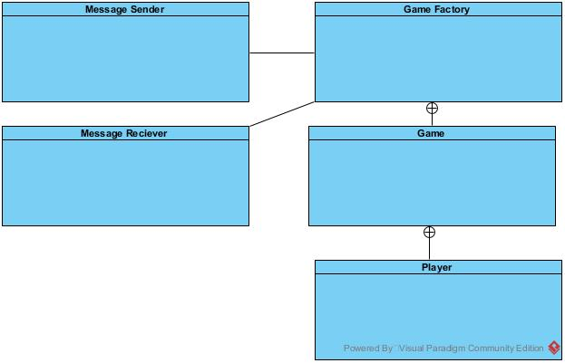

The Referee Server will contain a Game Factory Class. Inside the Game factory it will hold a queue of players. Once the queue has reached two players the game factory will create a game, and place the two players inside a game, and push that game into an array. The Game Factory will update the appropriate game when it isreceived from the messages. It will also controll word checking through the database server.

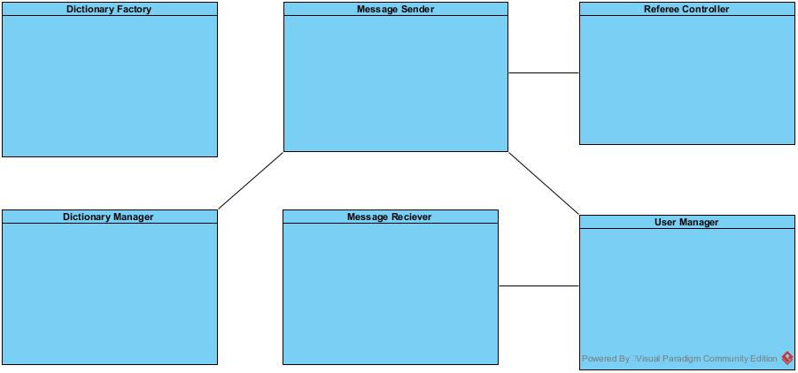

The database server will contain a User Manager that interfaces with a User database. The Dictionary factory will take a file of words, and create a database for that file. The Dictionary Manager will handle the queries to that database. The Referee controller will contro the XML file that will serve as the Referee IP, and Port log. This referee controller will be responsible for sending IP information to User Clients.

In total we will have three unique shared resources. A Dictionary Database, a Game object, and an XML file contained Referee Servers Registry.

